H.T No
Regulations:
A20

Sreenidhi Institute of Science and Technology
(An Autonomous Institution)
Code No: 8D301 Date: 16-Feb-2024 (FN)

B.Tech II-Year I- Semester External Examination, Jan/Feb-2024 (Supplementary)
DISCRETE STRUCTURE AND GRAPH THEORY(ECM)

Time: 3 Hours Max.Marks:70

Note: a) No additional answer sheets will be provided.
b) All sub-parts of a question must be answered at one place only, otherwise it will not be valued.
c) Missing data can be assumed suitably.
Bloom's Cognitive Levels of Learning (BCLL)

Remember | L1 | Apply | L3 | Evaluate | L5
Understand | L2 | Analyze | L4 | Create | L6

Part - A Max.Marks:20

Answer all QUESTIONS.

 |  | BCLL | CO(s) | Marks
1 | Construct the truth table for | L 2 | CO1 | [2M]
2 | Explain Quantifiers with Example. | L 2 | CO2 | [2M]
3 | What is Compatibility Relation? Give an Example | L 3 | CO3 | [2M]
4 | State Pigeon Hole Principle | L 2 | CO4 | [2M]
5 | Define Recurrence relation | L 3 | CO5 | [2M]
6 | State Differences between DFS and BFS | L 2 | CO6 | [2M]
7 | Prove that the proposition (P→Q) →(PΛQ) is contingency | L 3 | CO1 | [2M]
8 | Define Monoid and its properties. | L 2 | CO3 | [2M]
9 | What is inhomogeneous Recurrence Relation. Give an example. | L 3 | CO5 | [2M]
10 | Define Isomorphism on Graphs | L 2 | CO6 | [2M]

Part – B Max.Marks:50
ANSWER ANY FIVE QUESTIONS. EACH QUESTION CARRIES 10 MARKS.

 |  |  | BCLL | CO(s) | Marks
11. | a) | Explain the term Tautology?  Show that [(P→Q) →R] →[(P→Q) →(P→R)] is a Tautology. | L2 | CO1 | [5M]
 | b) | Obtain the PCNF of ¬(P→Q) Λ (Q↔P) | L3 | CO1 | [5M]
12. | a) | Symbolize the following argument and check for its validity  i) Every Living thing is a plant or animal  ii) David’s dog is alive and it is not a plant  iii) All animals have hearts.  Hence David’s dog has a heart. | L3 | CO2 | [5M]
 | b) | Prove that | L3 | CO2 | [5M]
13. | a) | Assume X = {1, 3, 5, 9, 15, 45} and Partial order relation is defined as, ∀x, y ∈ X, x divides y. Draw the Hasse diagram of the poset (X, /). | L3 | CO3 | [5M]
 | b) | Consider the function f: R→R defined by f(x)=2x+5. Let a function g: R→R be defined by g(x)= (x-5)^{1/2}. Prove that g is an inverse of f | L3 | CO3 | [5M]
14. | a) | There are 30 females and 35 males in the junior class, while there are 25 females and 20 males in the senior class. In how many ways can a committee of 10 be chosen so that there are exactly 5 females and 3 juniors on the committee? | L2 | CO4 | [5M]
 | b) | Determine the coefficients of a²b³c²d⁵ in the expansion of (a+2b-3c+2d+5)¹⁶ | L3 | CO4 | [5M]
15. | a) | Find a generating function for the recurrence relation  a_{n+2} - 3a_{n+1}+2a_{n}=0, n≥0, and a₀=1, a₁=6. | L3 | CO5 | [5M]
 | b) | Solve the Recurrence Relation  u_{n}+5u_{n-1}+6u_{n-2}=42(4)^{n} | L3 | CO5 | [5M]
16. | a) | Prove that the chromatic number of a tree and Bipartite graph is always 2 & chromatic number  of Complete graph K_{n} is n . | L3 | CO6 | [5M]
 | b) | Using Kruskal’s algorithm find a minimal spanning tree for the weighted graph shown below  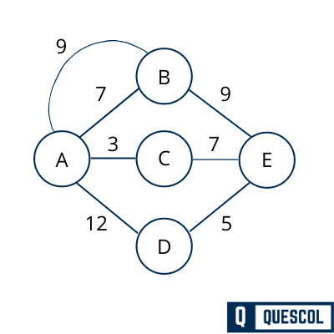 | L3 | CO6 | [5M]
17. | a) | Find the converse, inverse and contrapositive of the following propositions  i. P→(Q→R)  ii. (PΛ(P→Q)) →Q | L3 | CO1 | [4M]
 | b) | using automatic theorem proving prove the following  i. | L3 | CO2 | [3M]
 | c) | Let G be the set of real numbers not equal to -1 and * be defined by a*b = a+b+ab. Show that is an abelian Group. | L3 | CO3 | [3M]
18. | a) | How many ways can we get a sum of 4 or 8 when 2 distinguishable dice are rolled? How  many ways can we get an even sum? | L2 | CO4 | [4M]
 | b) | Solve the recurrence relation by substitution method a_{n} = a_{n-1} + n, n ≥ 1 where a_{o} = 2. | L3 | CO5 | [3M]
 | c) | Check whether the following graphs are Euler or Hamilton Graphs.  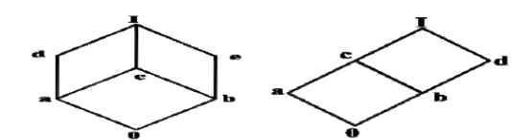 | L3 | CO6 | [3M]
-- 00 -- 00 –

